Ref: 42
Date: 18.06.2010

To Whom It May Concern:

I hereby certify that the below mentioned application for The First International Philosophy Congress which will be held by the Department of the Philosophy on October 14-16, 2010 in Bursa, Turkey, is accepted and registered as one of the papers of the Academic Programme of the Congress.

This document is issued upon the request of the applicant.

Sincerely yours,

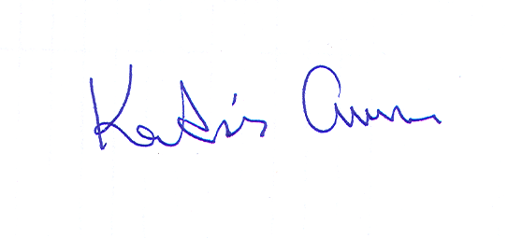
Prof. Dr. Abdulkadir Cucen
First International Philosophy Congress
Chair of Organising Committee

Application Record:
Paper’s Title | Preserving Societal Values Mechanisms in a Liberal Democracy - An Arabic Perspective
Full Name | Samir Abuzaid
Affiliation | The Egyptian Philosophical Society

